Hello Mark, hello Mona,
My name is Bernis.
My age is 10. I live in a big house. I live in the 5th floor. It is not a single house. Next year new balconies will be build. We have a playground in front of our house. When I look outside my window I can see the street and the busstation.
The place I prefer is the sofa and the bed in my room. I have many toys. My mother collects French dolls. Imagine, some of them are lighting in the dark.
The street I am living is called “Auf dem langen Kampe”, funny name,isn’t it ? In the springtime we have great Japanese cherry trees. Wonderful.
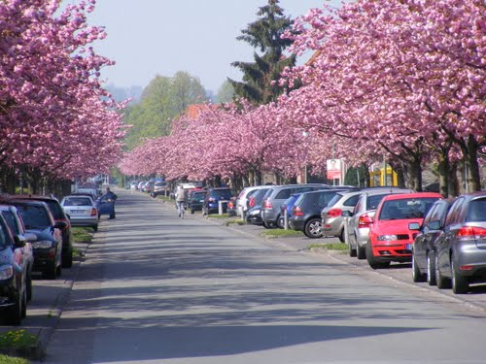
Here you can see some fotos from my home
Bernis
