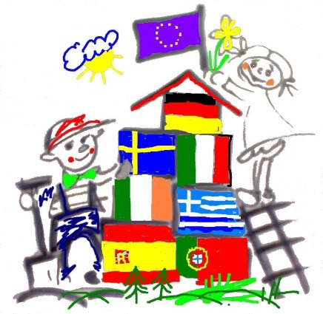
Hello Mark, hello Mona,
My name is Ernesa
My age is 10. In April is my birthday. I live together in one room with my sister. We don’t have pets at home. My uncle has a dog from Kosovo. My parents are from Kosovo, too. We have a room for the children, a living room, a parents room . My mother is at home and cleans the flat, every day.
Here you can see some fotos from my home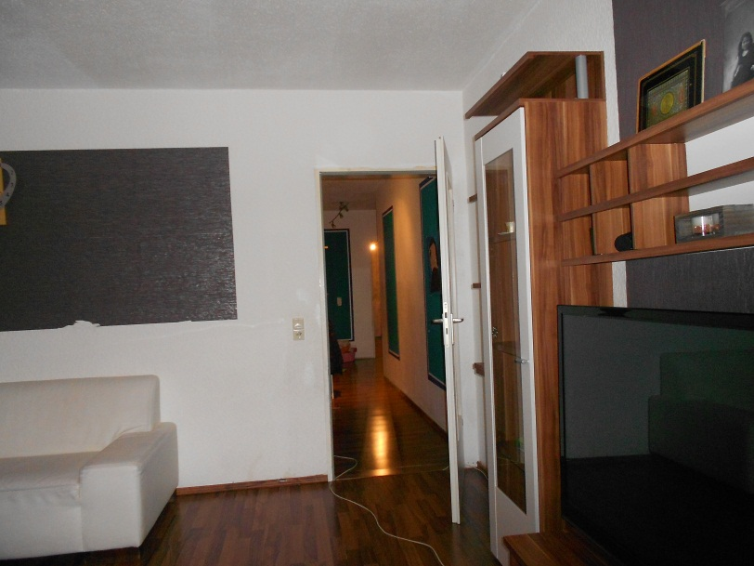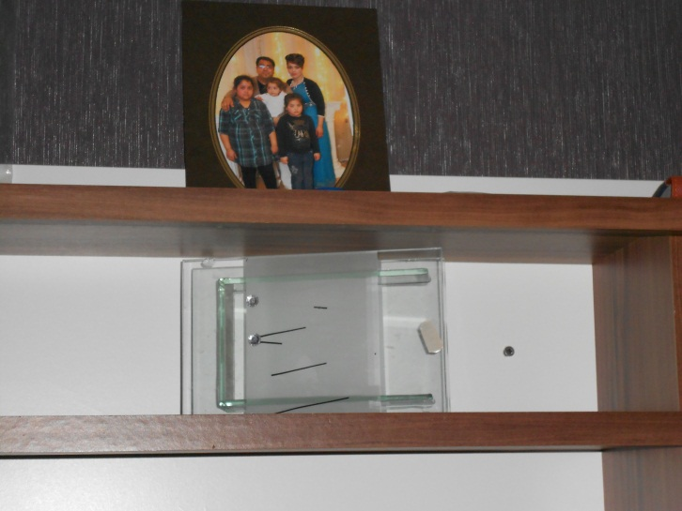 ERNESA

