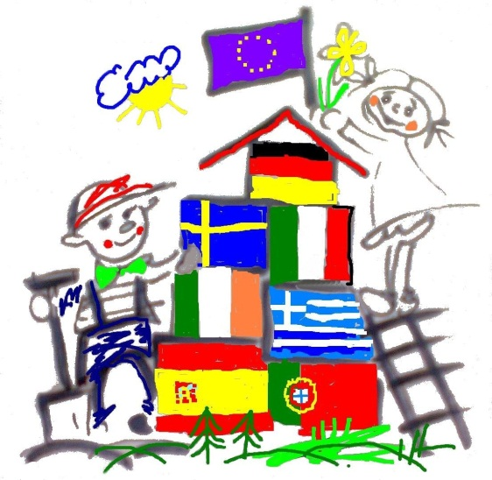
Hello Mark, hello Mona,
My name is Pascal. I am 11 years old. I am a student of class 5. My teacher ist Ms. Kohring.
I ive together with my mum and my sister laura. The street is called “An der Landwehr”
From my window I can see a supermarket called “JIBI” and a furniture shop and a factory.
I have my own room. I have a Computer, a bed, a television, a working desk an cupboards.
I like my room, I like to stay im my room. I have two cats, two turtles and two fish.
I don’t know the name of the race. Maybe they look like these friends.
Next week my teacher will give me a camera. I will make a foto of my little fish.
Pascal

