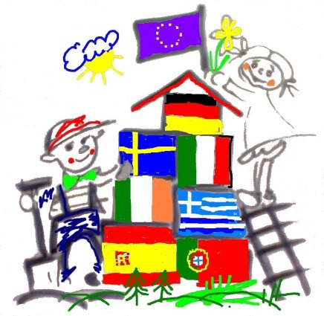
Hello Mark, hello Mona,
My name is Serhat. I am 10 years old. I am a Boy in class 5. I am living in a big house. We have Sauna, two living rooms and many, many rooms. We have a garden and 5 apple trees and a plum tree. We have a terrace , and a special room for storage. I like to sit in the livingroom on the sofa, or having fun in the garden. We have many beds. Imagine. We have four washing machines. We have a cat, called BinBin. My father renovated my room. He painted it white and he fixed up my bed. My brother Demhat is in class 7, my sister Evin went to a new school.My parents are from Kurdistan. You can see our religious symbol in one of the fotos.